City Crime Analysis Using Power BI
- Project Overview and Objective
This project involves cleaning, transforming, and analysing raw data using Excel and creating an interactive Power BI dashboard to derive meaningful business insights.
The main objective is to demonstrate data pre-processing techniques using Excel and an interactive Power BI dashboard visualization to make informed decisions.

- Data Sources
- Source Description and Timeline: Google dataset/2025.
- Domain: Environment

- Problem Statement
- Crime data is large and complex, making it difficult for stakeholders to quickly understand overall crime trends and patterns across districts and time periods.
- There is a lack of a centralized and interactive system to identify high-crime districts, wards, and offense types for effective public safety planning.
- Decision-makers struggle to analyze how crime varies by time (year and shift), limiting their ability to deploy resources efficiently.
- Existing reports do not provide drill-down capabilities to explore detailed crime information from a high-level summary.
- Without clear visual insights and trend analysis, it is challenging to monitor changes in crime levels and identify emerging hotspots.

- Attribute (Column /Features) Details:
Attribute Name | Attribute Nam | Description
CCN | Text / Integer | Central Complaint Number – unique identifier for each crime incident
REPORT_DAT | Date/Time | Date and time when the crime was reported
Report year | Integer | Year in which the crime was reported
SHIFT | Text | Time shift when the crime occurred (DAY, EVENING, MIDNIGHT)
OFFENSE | Text | Type of crime committed (e.g., Theft, Assault, Robbery)
METHOD | Text | Method used to commit the crime
DISTRICT | Text | Police district where the crime occurred
WARD | Integer / Text | Administrative ward of the crime location
PSA | Integer | Police Service Area responsible for the location
NEIGHBORHOOD_CLUSTER | Text | Grouped neighborhood classification
BLOCK | Text | Street block where the crime occurred
LATITUDE | Decimal Number | Latitude coordinate of the crime location
LONGITUDE | Decimal Number | Longitude coordinate of the crime location
XBLOCK | Decimal Number | X-coordinate for spatial mapping
YBLOCK | Decimal Number | Y-coordinate for spatial mapping

5. Tools & Technologies
- Excel: Data cleaning, transformation, and Pivot Tables.
- Power BI: Data modelling, DAX calculations, visualization, and interactive dashboard creation.

6. Data Pre-Processing (Excel / Power Query)
Tasks Performed:
- Data Cleaning & Transformation: Removed duplicates, handled missing values, standardized formats, and created calculated fields.
- Filtering & Sorting: Organized data to focus on relevant records.
- Pivot Tables: Generated Pivot Tables for data summarisation and initial insights.

7. Data Modelling and DAX (Power BI)
- Calculated Columns & DAX Measures: Implemented DAX formulas for key metrics, such as total sales, growth percentages, and cumulative totals.
      - Total Crimes
      - Crimes by Offense
      - Crimes by District
      - Crimes by shift
      - Crimes Trend by year
      - Crimes by Ward

8. Analysis and Visualizations (Power BI)
Dashboard Features:
- Multiple Visualizations based on problem statement: Bar charts, line charts, pie charts, cards, and tables to communicate insights.
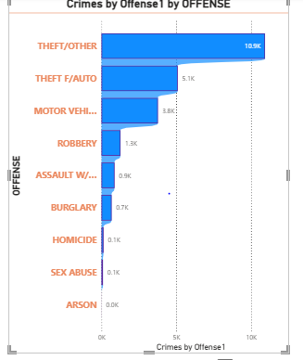
- THEFT/OTHER is the highest offense category with ~10.5K cases, followed by THEFT FROM AUTO (~5.1K).
- THEFT FROM AUTO (5.1K) and MOTOR VEHICLE THEFT (3.8K) together form a significant portion of offenses.
- Serious violent offenses like ROBBERY (1.3K), ASSAULT WITH WEAPON (0.9K), and HOMICIDE (0.1K) are comparatively low.
- Homicide, Sex Abuse, and Arson show very low counts, but their social impact is extremely high.

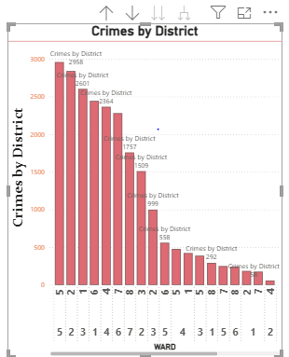
    - The top 3 districts record ~2,600–2,950 crimes each, significantly higher than the rest.
    - After the top 5 districts, crime counts fall rapidly from ~1,500 to below 1,000.
    - The lowest districts report fewer than 200 crimes.
    - Since crime volume varies greatly by district, resource allocation should be district-specific rather than uniform.
    - Focusing enforcement and prevention strategies on high-crime districts could significantly reduce overall crime.

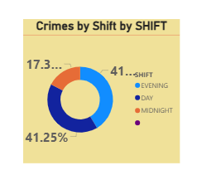
    - The Evening shift accounts for ~41% of total crimes, making it the most crime-prone time period.
    - The Evening shift accounts for ~41% of total crimes, making it the most crime-prone time period.
    - The Day shift also contributes ~41%, nearly equal to the evening shift.
    - Since over 80% of crimes occur during Day and Evening shifts, law enforcement and preventive measures should prioritize these periods.
    - Strategic staffing during these shifts could yield the maximum impact on crime reduction.

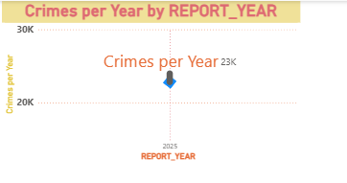
  - The dataset shows approximately 23K crimes in the reported year (2025).
  - Viewing crime data by year helps identify macro-level patterns rather than short-term fluctuations.
  - The visualization indicates crime records are heavily concentrated in one reporting year, suggesting the dataset may represent recent or current crime conditions.
  - Using REPORT_YEAR as a slicer or drill-down level enables users to analyze districts, offenses, and shifts for that specific year.
  - This allows stakeholders to pinpoint where and when crimes are increasing within the year.

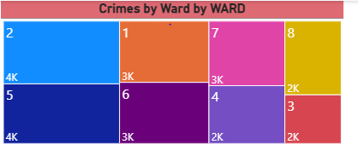
  - Wards 2 and 5 show the highest crime counts (~4K each).
  - Wards 1, 6, and 7 each report ~3K crimes.
  - Wards 3, 4, and 8 have ~2K crimes each, which is lower comparatively but still significant.
  - This suggests crime is present across all wards, not limited to just high-crime areas.
  - The clear variation in crime across wards supports ward-specific policing strategies.
  - Focusing interventions on top wards (2 and 5) can deliver the highest impact on overall crime reduction.

Consolidated Report /Dashboard.
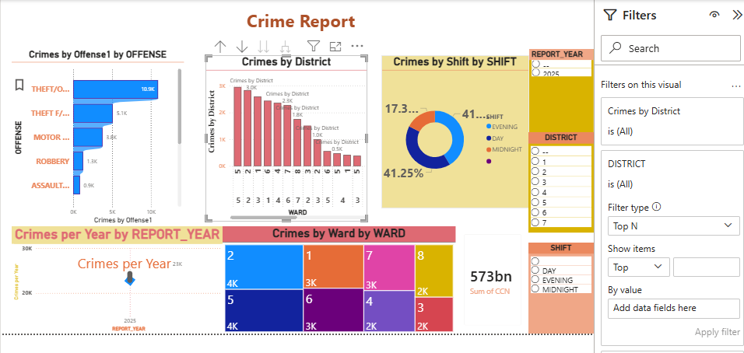

9. Insights & Conclusions
Descriptive Analytics:
    - Purpose: Summarizes historical crime data.
    - Shows total crimes, crimes by offense, district, ward, shift, and year.
    - Identifies highest crime districts, top offenses, and peak shifts.
    - Example Measure: Total Crimes, Crimes by Offense, Crimes by District

Diagnostic Analytics:
Purpose: Explains reasons behind crime patterns.
    - High crime in certain districts may be due to population density, commercial areas, or vehicle traffic.
    - Higher crime during Day and Evening shifts reflects increased public activity.
    - Vehicle theft dominance indicates parking and transit areas as vulnerable zones.
    - Example Measure: Crimes by Shift, Crimes by Ward, Crimes by District

Predictive Analytics:
Purpose: Forecasts future crime trends based on patterns.
    - Districts and wards with historically high crime are likely to remain hotspots.
    - Theft and vehicle-related crimes are expected to continue dominating future incidents.
    - Day and Evening shifts may continue to record higher crime volumes.
    - Example Measure: Crimes per Year, Crimes by Offense Trend

Prescriptive Analytics:
Purpose: Recommends actions to reduce crime.
    - Increase patrol and surveillance in top crime districts and wards.
    - Strengthen vehicle security measures in high-risk areas.
    - Allocate more staff during Day and Evening shifts.
    - Implement ward-specific and offense-specific prevention programs.
    - Example Measure: Top 10 Offenses, High-Crime Districts

10. Conclusions
- The analysis reveals that crime is predominantly driven by theft and vehicle-related offenses, with incidents concentrated in specific districts and wards. Most crimes occur during Day and Evening shifts, indicating higher risk during active public hours. These insights enable targeted, data-driven strategies for effective crime prevention and resource allocation.

